Process Synchronization
Introduction:-
Process Synchronization means sharing system resources by processes in such a way that, Concurrent access to shared data is handled thereby minimizing the chance of inconsistent data. Maintaining data consistency demands mechanisms to ensure synchronized execution of cooperating processes.
When two or more process cooperates with each other, their order of execution must be preserved otherwise there can be conflicts in their execution and inappropriate outputs can be produced.
A cooperative process is the one which can affect the execution of other process or can be affected by the execution of other process. Such processes need to be synchronized so that their order of execution can be guaranteed.
The procedure involved in preserving the appropriate order of execution of cooperative processes is known as Process Synchronization. There are various synchronization mechanisms that are used to synchronize the processes.
The Producer Consumer Problem:-
A cooperating process that can have an effect on by other processes executing in the system. Cooperating processes can either directly share both code and data or allowed to share data only through files or messages. Concurrent access to shared data may result in data inconsistency. We show producer-consumer problem. How bounded buffer could be used to enable processes to share memory.
A bounded buffer could be used to enable processes to share memory. While considering the solution for producer – consumer problem, it allows BUFFER_SIZE – 1 item in the buffer. If the algorithm can be modified to mixture this deficiency, one possibility is to add an integer variable counter initialized to 0. Counter is incremented every time a new item is added to the buffer and is decremented every time, an item is removed from the buffer.
The code for the producer process:
While (true)
{
/*produce an item in next Produced*/
While (counter == BUFFER_SIZE)
/*do nothing*/
Buffer [In] = next Produced;
In = (In+1) % BUFFER_SIZE;
Counter++;
}

The code for the consumer process:

While (true)
{
While (counter == 0)
/ *do nothing* /
Next Consumed = buffer [out];
Out = (out+1) % BUFFER_SIZE;
Counter--; / *consume the item in next Consumed* /
}

If both producer and consumer functions are execute separately it gives correct result, but when executed concurrently it gives incorrect result. suppose counter value is 5, then producer and consumer execute the statements "counter++" & "counter- –“ concurrently that time variable counter value may be 4, 5, or 6. Only correct result is counter value is 5, if the producer and Consumer execute separately.
Statement "counter++"is implemented as follows:
register₁=counter
register₁= register₁+1
Counter= register₁
The statement "counter--"is implemented as follows:
register₂ ₌ counter
register₂₌ register₂ ₋ 1
Counter= register₂
Concurrent execution of "counter++ "&" counter -- "is equivalent to a sequential.

T_{o}: producer execute register₁ = counter (register₁=5)
T₁: producer execute register₁ = register₁ + 1 (register₁=6)
T₂: consumer execute register₂ = counter (register₂=5)
T₃: consumer execute register₂ = register₂ - 1 (register₂=4)
T₄: producer execute counter = register₁ (counter= 6)
T_{s}: consumer execute counter = register₂ (counter= 4)

The "counter=4" indicates that four buffers are full; in fact five buffers are full. If we reversed the order of the statements at T₄ and T₅, we would arrive at the incorrect state "counter=6". We arrive at this incorrect state because we allowed both processes T_{o} manipulate the variable counter concurrently. A situation is, several processes access and use the same data concurrently and the result of the execution depends on the particular order in which the access Takes place, is called a race condition. To security against the race condition, we need only one process at a time can be using the variable counter. We require that Process synchronization and coordination.

- Critical-Section Problem
A system consisting of n number of processes {P0, P1, and P2....P_{n-1}}. Each process has a segment of code where the shared memory is accessed, called a critical section, in which the process may be changing common variables, updating a table, writing a file. When one process is executing in its critical section, no other process is to be allowed to execute in its critical section. That is, no two processes are executing in their critical sections at the same time. The critical-section problem is to design a set of rules that the processes can use to cooperate. Each process takes a permission to enter its critical section.

- Entry Section: Code requesting entry into the critical section.
- Critical Section: Code in which only one process can execute at any one time.
- Exit Section: The end of the critical section, releasing or allowing others in.
- Remainder Section : Rest of the code AFTER the critical section
do {
Entry section

Critical section
Remainder section

} while (TRUE);
General Structure of a typical process
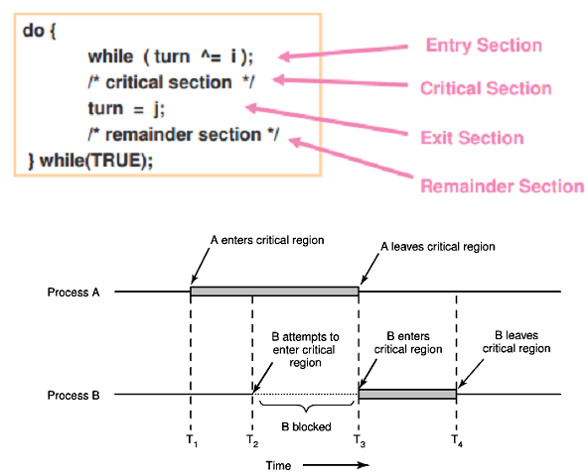
A solution to the critical-section problem must satisfy the following three requirements:
1. Mutual Exclusion: If process P_{i} is executing in its critical section, then no other processes can be executing in their critical sections.

2. Progress: If no process is executing in its critical section and there exist some processes that wish to enter their critical section, then the selection of the processes that will enter the critical section next cannot be late for an indefinite period.

3. Bounded Waiting: A bound must exist on the number of times that other processes are allowed to enter their critical sections after a process has made a request to enter its critical section and before that request is granted.

Two-Process Solutions
Algorithms applicable to only two processes at a time. The processes are P_{o} and P₁.
Algorithm 1
The processes share a common integer variable turn initialized to 0 or 1. If turn == i, then process Pi is allowed to execute in its critical section.
do {
While (turn!=i );
// No Operation //
Critical section
turn=j;
Remainder section
} while (1);
The structure of process P_{i} in algorithm 1.
This solution to allow only one process at a time can be in its critical section. It does not satisfy the progress requirement. Example, if turn == 0 and P₁ is ready to enter its critical section, P₁ cannot enter, still while Po may be in its remainder section.

Algorithm 2
The problem of algorithm 1 is it does not keep sufficient information about the condition of each process; it remembers only which process is allowed to enter its critical section. To solve this problem, we can replace the variable turn with the following array:
Boolean flag [2];
The elements of the array are initialized to false. If flag [ i ] is true, this value indicates that Pi is ready to enter the critical section.
do {
flag [ i ] = true;
While (flag [ j ] );
Critical section
flag [ i ] = false;
Remainder section
} while (1);
The structure of process Pi in algorithm 2.
Process Pi first sets flag [i] to be true & signal that it is ready to enter its critical section. Then, Pi checks to verify that process Pi is not also ready to enter its critical section. If Pi were ready, then Pi would wait until Pi had indicated that it no longer needed to be in the critical section (pending flag[ j ] was false) Pi would enter the critical section. On exiting the critical section, Pi would set flag [ i ] to be false, allowing the other process (if it is waiting) to enter its critical section.
In this solution, the mutual-exclusion requirement is satisfied. The progress requirement is not met. This problem, we consider the following execution sequence:
T_{o}: P_{o} sets flag [0] = true
T₁: P₁ sets flag [l] = true
Now P_{o} and P₁ are looping forever in their respective while statements. This algorithm is importantly dependent on the exact timing of the two processes. The sequence derived in an environment where several processors executing concurrently, or where an interrupt occurs immediately after step T_{o} is executed, and the CPU is switched from one process to another. The switching the order of the instructions for setting flag [i], and testing the value of a flag [j], will not solve our problem. Both processes to be in the critical section at the same time, violating (Break rule of) the mutual-exclusion requirement.

Algorithm 3
By combining ideas of algorithm 1 and algorithm 2, we require all three requirements are met. The processes share two variables:
Boolean flag [2];
int turn;
The variable turn indicates whose turn it is to enter its critical section. The flag array is used to indicate if a process is ready to enter its critical section. Initially flag [0] = flag [1] = false, and the value of turn is either 0 or 1.
do {
flag [i] = true;
turn = j;
while ( flag [j] && turn = = j );
critical section
flag [ i ] = false;
remainder section
} while (1);
The structure of process Pi in algorithm 3.

To enter the critical section, process Pi first sets flag [i] to be true and then sets turn to the value j, if the other process wishes to enter the critical section it can execute. If both processes try to enter at the same time, turn will be set to both i and j at roughly the same time. Only one of these assignments will last; the other will occur, but will be overwritten immediately. The eventual value of turn decides which of the two processes is allowed to enter its critical section first. We now prove that this solution is correct. We need to show that two processes P₀ and P₁:
1. Mutual exclusion: P₀ and P₁ can never be in the critical section at the same time: If P₀ is in its critical section, then flag [0] is true and either flag [1] is false (meaning P₁has left its critical section) or turn is 0 (P₁ is just now trying to enter the critical section, but kindly waiting). In both cases, P₁ cannot be in critical section when P₀ is in critical section.

2. Progress: Each process can only be blocked at the while if the other process wants to use the critical section (flag[j] = = true), & it is the other process's turn to use the critical section (turn = = j). If both of those conditions are true, then the other process (j) will be allowed to enter the critical section, and upon exiting the critical section, will set flag[j] to false, releasing process i. The shared variable turn assures that only one process at a time can be blocked, and the flag variable allows one process to release the other when exiting their critical section.

3. Bounded waiting: As each process enters their entry section, they set the turn variable to be the other processes turn. Since no process ever sets it back to their own turn, this ensures that each process will have to let the other process go first at most one time before it becomes their turn again

- Semaphore:
It is a synchronization tool that is used to simplify the solution to the critical section problem (To avoid race condition). A Semaphore s is an integer variable that can only be accessed via two indivisible (atomic) operations namely
1. Wait or P operation (to test)
2. Signal or V operation (to increment)
The definition of wait ( ) is as follows: The definition of signal ( ) is as follows:

Wait (S) signal (S)
{ {
While ( S <= 0 ) S++;
// no-operation; }
S--;
}
All modifications to the integer value of the semaphore in the wait ( ) and signal ( ) operations must be executed separately. When one process modifies the semaphore value, no other process can simultaneously modify that same semaphore value.
Usage: Semaphore is two types
Counting Semaphores: The value of a counting semaphore can range over an unlimited.
Binary Semaphores: The value of a binary semaphore can range only between 0 and 1. Binary semaphores are known as mutex locks, as they are locks that provide mutual exclusion. We can use binary semaphores to deal with the critical-section problem for
Multiple processes. Then processes share a semaphore, mutex, initialized to 1.
Each process Pi is organized as shown in figure.
do{
wait ( mutex ) ;
//critical section
Signal ( mutex );
//remainder section
} while(TRUE);
Mutual-exclusion implementation with semaphores.
We can also use semaphores to solve various synchronization problems. Example, consider two concurrently running processes: P1 with a statement S1 and P2 with a statement S2. Suppose we require that S2 be executed only after S1 has completed. P1 and P2 share a common semaphore synch, initialized to 0, and by inserting the statements in process P2.
S1;
signal(synch) ;
in process P1 and the statements
wait(synch);
S2;
Because synch is initialized to 0, P2 will execute 52 only after P1 has invoked signal (synch), which is after statement 51 has been executed.

- Semaphore Implementation
- The main disadvantage of the semaphore is busy waiting. While a process is in its critical section, any other process that tries to enter its critical section must loop continuously in the entry section. This continual looping is clearly a problem in a real multiprogramming system.
- Busy waiting wastes CPU cycles but that some other process might be able to use efficiently. This type of Semaphore is also called a spinlock because the process "spins" while waiting for the lock. (Spin locks have an advantage in that no context switch is required when a process must wait on a lock, and a context switch may take consider able time).
- To overcome busy waiting problem, modify the definition of the semaphore operations wait ( ) and signal ( ).
- When a process executes the wait operation and finds semaphore value. When semaphore value is negative, the process can block itself. The block operation places the process into a waiting queue associated with the semaphore.
- A process that is blocked waiting on a semaphore should be restarted when some other process executes a signal ( ) operation. The blocked process should be restarted by a wakeup ( ) operation which put that process into ready queue.
- To implement semaphores under this definition :
typedef struct {
int value ;
struct process*list ;
} semaphore;

Each semaphore has an integer value and a list of processes list .When a process must wait on a semaphore; it is added to the list of processes. A Signal ( ) operation removes one process from the list of waiting processes and awakens that process.
The wait ( ) semaphore operation can now be defined as
Wait (semaphore*S)
{
S -> value --;
if ( S -> value < 0 )
{
add this process to S -> list ;
block ( ) ;
}
}
The signal ( ) semaphore operation can now be defined as
Signal (semaphore*S)
{
S -> value++;
If ( S -> value <= 0 )
{
remove a process P from S -> list ;
wakeup (P);
block suspends the process that invokes it. wakeup(P) resumes the execution of a blocked process P.
The definition of semaphores with busy waiting the semaphore value is never negative. If the semaphore value is negative, its total is the number of processes waiting on that semaphore. We haven’t completely eliminate busy Waiting with this definition of the wait ( ) and signal ( ) operations. Rather, we have removed busy waiting from the entry section to the critical sections of application programs. Limited busy waiting to the critical sections of the wait ( ) and signal ( ) operations.

- Deadlocks and Starvation:
The implementation of a semaphore with a waiting queue may result in a condition where two or more processes are waiting in completely for an event that can be caused only by one of the waiting processes. We consider a system consisting of two processes, P₀ & P₁, each accessing two semaphores, S and Q, set to the value 1:
P₀ P₁
wait ( S ) ; wait ( Q ) ;
wait ( Q ) ; wait ( S ) ;
signal ( S ) ; signal ( Q ) ;
signal ( Q ) ; signal ( S ) ;

- Suppose that P₀ executes wait(S), then P₁ executes wait (Q). When P₀ executes wait (Q), it must wait until P₁ executes signal (Q).Similarly when P₁ executes wait(S), it must wait until P0 executes signal(S). Since these signal operations cannot be executed, P₀ & P₁ are deadlocked.
- Another problem related to deadlock is indefinite blocking or starvation, a situation where a process wait indefinitely within the semaphore. Indefinite blocking may occur if we add or remove processes from the list associated with a semaphore in LIFO order.

Classic Problems of Synchronization:
- Bounded-Buffer Problem
- Readers and Writers Problem
- Dining-Philosophers Problem
- The Bounded-Buffer Problem:
To avoid the occurrence of race condition, we present a solution to the bounded buffer problem using semaphores. The biggest advantage of this solution using semaphores is that it not only avoids the occurrence of race condition but also allows having size items in the buffer at the same time, thus, eliminating the shortcomings of the solutions using shared memory.
We assume that the pool consists of n buffers, each capable of holding one item.
The mutex semaphore provides mutual exclusion for accesses to the buffer pool and is initialized to the value 1. The empty and full semaphores count the number of empty and full buffers. The semaphore empty is initialized to the value n; the semaphore full if initialized to the value 0.
The code for the producer process is:
do {
// produce an item in next p
wait (empty);
wait (mutex);
// add next p to buffer
signal (mutex);
signal (full);
} while (TRUE),

The code for the consumer process is:
do {
wait (full);
wait (mutex);
// remove an item from buffer to next c
signal (mutex);
signal (empty);
// consume the item in nextc
} while (TRUE);
We can interpret this code as the producer producing full buffers for the consumer or as the consumer producing empty buffers for the producer.

- The Readers-Writers Problem:
Concurrently executing processes that are sharing a data object, such as a file or a
variable, fall into two groups: readers and writers. The processes in the readers group want only to read the contents of the shared object & the processes in writers group want to update (read and write) the value of shared object. There is no problem if multiple readers access the shared object simultaneously. However, if a writer and some other process (either a reader or writer) access the shared object simultaneously, data may become inconsistent.
To guarantee that such a problem does not occur, when a Writer is accessing the shared object, no reader or writer accesses that shared object. This synchronization problem is termed as readers-writers problem has several variations.
- First reader-writer problem requires that no reader will be kept waiting excepting a writer gives permission to use the shared object. No reader should wait for others readers to finish simply because a writer is waiting.
- Second readers-writers problem if a writer is ready, that writer performs its write as soon as possible. if a writer is waiting to access the object, no new readers may start reading.
A solution to problem can result in starvation. In the first case writers may starve, in the second case readers may starve. A solution to the first readers-writers problem. The reader process share the following data structures:
semaphore mutex, wrt;
int readcount;
The semaphore mutex and wrt are initialized to 1 and readcount is initialized to 0.
The semaphore wrt is common to both reader and writer processes. The mutex semaphore is used to ensure mutual exclusion when the variable readcount is updated. The readcount variable keeps track of how many processes are currently reading the object. The semaphore wrt functions as a mutual-exclusion semaphore for the writers. It is also used by the first or last reader that enters or exist the critical section. It is not used by readers who enter or exit while other readers are in their critical section.
If a writer is in the critical section and n readers are waiting, then one reader is
queued on wrt, and n-1 readers are queued on mutex. Also, observe that, when a
writer executes signal(wrt), we may resume the execution of either the waiting readers or a single waiting writer.
The structure of a writer process.
do {
wait (wrt);
// writing is performed
signal (wrt);
} while (TRUE);
The structure of a Reader process.
do {
wait (mutex);
read_count+ + ;
if (read_count ==1)
wait (wrt);
signal (mutex);
// reading is performed
wait (mutex);
read_count --;
if (read_count ==0)
signal (wrt);
signal (mutex);
} while(TRUE);

The Dining-Philosophers Problem:
Consider five philosophers sitting around a circular table. There is a bowl of rice in the centre of the table and five chopsticks – one in between each pair of philosophers.
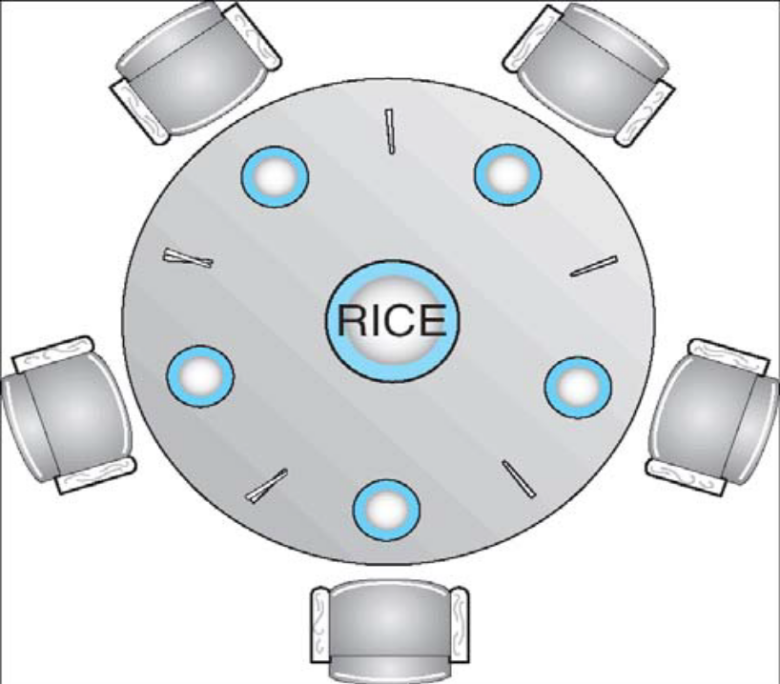
Figure : The situation of the dining philosophers.
- These philosophers spend their lives alternating between two activities: eating and
thinking.
- When it is time for a philosopher to eat, it must first acquire two chopsticks - one from their left and one from their right.
- When a philosopher thinks, it puts down both chopsticks in their original locations
One simple solution is to represent each chopstick with a semaphore. A philosopher tries to take a chop stick by executing a wait () operation on that semaphore; she releases her chopsticks by executing the signal () operation on the correct semaphores. Thus, the shared data are Semaphore chopstick [5]; where all elements of chopstick are initialized to 1.This solution is rejected as it could create a deadlock. Suppose that all five philosophers become hungry simultaneously and each take her left chopstick. All the elements of chopstick will now be equal to 0. When each philosopher tries to takes her right chopstick, she will be delayed forever.
do {
wait (chopstick [i] );
wait (chopstick [(i+l) % 5 ] );
// eat
signal (chopstick [i] );
signal (chopstick [(i+l) % 5 ] );
// think
} while (TRUE);
Some potential solutions to the problem include:
- Only allow four philosophers to eat dinar at the same time. (Limited simultaneous processes.)
- Allow philosophers to pick up chopsticks only when both are available, in a critical section. (All or nothing allocation of critical resources.)
- Use an asymmetric solution, in which odd philosophers pick up their left chopstick first and even philosophers pick up their right chopstick first.

A deadlock-free solution to the dining philosopher’s problem does not automatically guarantee a starvation-free one.

- Critical Regions:
Semaphores provide a suitable and effective system for process synchronization, their incorrect use can still result in timing errors that are difficult to detect, since these errors happen only if some particular execution sequences take place occur.
Some of the problems that can be generated by the incorrect usage of semaphores to solve the critical section problem
- Suppose that a process interchanges the order wait and signal operations on the semaphore mutex are executed, resulting in the following execution, where several processes may be executing in their critical section simultaneously, violating the mutual-exclusion requirement.
signal (mutex) ;
. . .
critical section
. . .
wait (mutex) ;
- Suppose that a process replaces signal (mutex) with wait (mutex). That is, it executes
wait (mutex) ;
. . .
critical section
. . .
wait (mutex) ;
In this case, a deadlock will occur.
- Suppose that a process omits the wait (mutex), or the signal (mutex), or both. In this case, either mutual exclusion is violated or a deadlock will occur.
To deal with the type of errors we have outlined, a number of high-level language constructs have been introduced. The critical-region high-level language synchronization construct requires that a variable v of type T, which is to be shared among many processes, be declared as
v : shared T;
The variable v can be accessed only inside a region statement of the following form:
region v when B do S;
This construct means that, while statement S is being executed, no other process can access the variable v. The expression B is a Boolean expression that governs the access to the critical region. When a process tries to enter the critical-section region, the Boolean expression B is evaluated. If the expression is true, statement S is executed. If it is false, the process relinquishes the mutual exclusion and is delayed until B becomes true and no other process is in the region associated with v.
region v when (true) S1;
region v when (true) S2;
Thus, if the two statements are executed concurrently in distinct sequential processes, the result will be equivalent to the sequential execution "S1 followed by S2” or "S2 followed by Sl."
The critical-region construct guards against certain simple errors associated with the semaphore solution to the critical-section problem that may be made
by a programmer. it does not necessarily eliminate all synchronization errors; rather, it reduces their number. If errors occur in the logic of the program, reproducing a particular sequence of events may not be simple.

Assignment Questions
Q.1 Explain in brief race condition?
Q.2 Explain critical section Problem with example?
Q.3 what are the requirement for critical section problem?
Q.4 what are semaphores? How do they implement mutual exclusion?
Q.5 Explain the classical problem of synchronization?
Q.6 what is the meaning of term busy-waiting and spinlock ?

Questions
Q-1) What do you mean by Semaphores and Semaphores used in concurrent system?
Q-2) What is meant by critical section problem? How can semaphores be used for process synchronization? Explain.
Q-3) What is Semaphore? Define P & V Operations on semaphores. Also explain Bounded-Buffer problem.
Q-4) What are the three requirements that a solution to the critical section problem must satisfy? Also explain Bounded-Buffer problem.
Q-5) Define Semaphores. In which cases are used? Explain how these can be implemented?
Q-6) What are the three requirements that a solution to the critical section problem must satisfy?
Q-7) What are semaphores? How do they implement mutual exclusion? What are the different types of semaphores? How can they be implemented?
Q-8) What is critical section problem?
Q-9) Describe how semaphores can be used for block/wakeup synchronization between processes.

